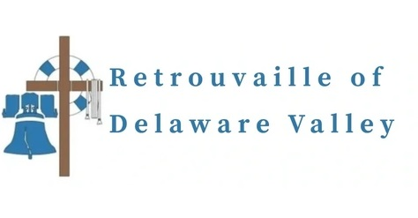

RETROUVAILLE: REDISCOVER THE LOVE IN YOUR MARRIAGE
Tens of thousands of couples have healed their marriages through Retrouvaille (pronounced Retro-vy).
If you know anyone who could benefit from this program, please pass this on. Couples learn to build communication skills and to increase intimacy. It provides help for marriage problems, difficulties or crises.
The next program begins the weekend of July 31 - August 2, 2026 at the Family Life Center in Malvern, PA.
For more information, or to register, call 215-766-3944 or visit www.MarriageHelpDelVal.org. All inquiries are strictly confidential.

