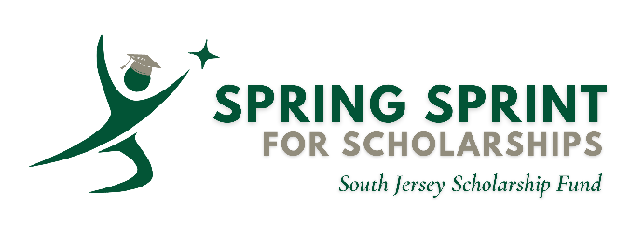

Support the South Jersey Scholarship Fund’s Spring Sprint for Scholarships appeal running now through June 30. In the 2025-26 school year, the fund provided scholarship assistance for 179 Catholic school students in the Diocese of Camden. For many of these families, this support enabled them to continue sending their children to Catholic school.
For more information or to contribute, visit southjerseyscholarshipfund.org
To donate offline, please send payment to:
South Jersey Scholarship Fund
631 Market Street
Camden, NJ 08102

