Learn how to protect your loved ones and create your Catholic Legacy
at the Diocese of Camden’s Planned Giving Workshop
Tuesday, May 19th 6:45 p.m.
Holy Eucharist Parish
Kresson Rd., Cherry Hill, NJ
Presented by
Patrick W. McGrory, PhD, CFP®, CRPC®
Founder and Private Wealth Advisor
Liberty Point Advisors
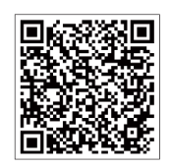
Learn about estate planning (and making sure yours is up-to-date),
charitable gift annuities, and other planned-giving opportunities
To register, please scan the
code to the right

For more information, please email stephanie.corro@camdendiocese.org

