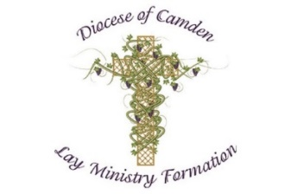

- Are you a practicing Catholic who is hungry for more knowledge about Catholic teaching?

- Are you in ministry with a desire to increase your knowledge about God and about the Church you serve?
CMIC—Church Ministry Institute Camden offers courses for you!
Cape May Court House, CMIC Courses on Mondays, 4:00 to 6:30 p.m.
Email: Joanne Kelly, joanne@ourladyoftheangels.net

Cherry Hill, CMIC Old Testament – Tuesdays, September 17, for 6 weeks, 7:00 to 9:30 p.m.
Email: Cathy Johnson, cjohnson@christourlight.net

Gibbsboro, New Testament – Thursdays, September 26, for 10 weeks, 7:00 to 8:30 p.m. Email: Jim Hemschoot, jhemschoot@churchofstandrews.org

Collingswood, CMIC Prayer – Wednesdays, October 2, for 6 weeks, 7:00 to 9:30 p.m. Email: Cheryl Venafra, cvenafra@stteresaofcalcuttanj.org

Mays Landing, CMIC Foundations of Faith – Wednesdays, October 9, for 6 weeks, 6:30 - 9:00 p.m. Email: Kathy Mattson, stvincentdepaulmayslanding@verizon.net

