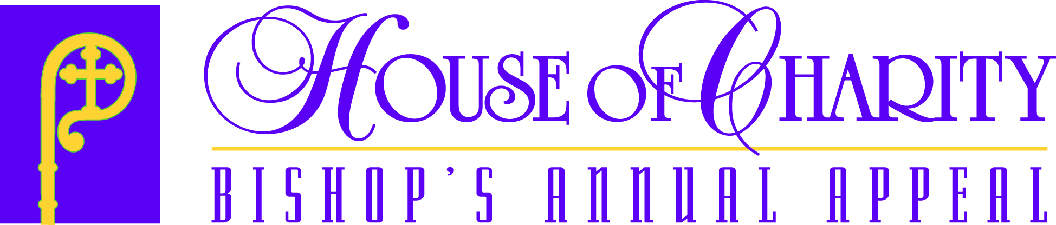

2019 Parishioner Mailings

Winter and Summer Campaigns

Parish does first Follow-up Mailing
in April (winter parishes) or July (summer parishes)

Lapsed Donors (Last gift 2016 or 2015)

2018, 2017 Donors;
New Members

Long-Lapsed Donors
(Last gift 2014 through
2011)
Disengaged Donors (Last gift 2010 or 2009) and Non-Donors

& Non-Donors
- DEC/JAN: Annual Report
- JAN/APR: Brochure, Letter & Pledge Card mailing (phased)
- JULY: Diocesan Follow-up
- SEPT: All-in-One Follow-up

- DEC/JAN: Annual Report
- JAN/APR: Brochure, Letter & Pledge Card mailing (phased)
- JULY: Diocesan Follow-up
- SEPT: All-in-One Follow-up

- JAN/MAY: Personalized All-in- One Brochure
- JULY: Diocesan Follow-up

- JAN/MAY: Generic All-in-One Brochure
- JULY: Diocesan Follow-up

Remember to forward pledges and checks to the Appeal Office
within one week of receipt. This ensures that all donors are accounted for
and allows for more accurate follow-up mailings.

You Did It for Me

REV 11/28/2018

