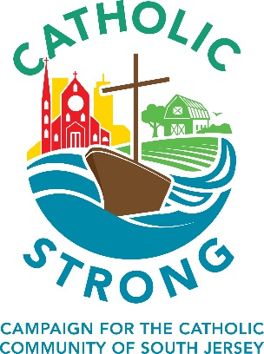

The Catholic Strong Campaign is a Local Campaign

Unlike most diocesan-wide campaigns of this nature, the Catholic Strong campaign returns 70% of the funds raised directly back to the parish. This is virtually unheard of in the world of fundraising.

Bishop Dennis Sullivan has seen first-hand the great work being done in the parishes. Catholic Strong was designed to support the development of needed initiatives that help our local Catholic communities continue to grow, strengthen and welcome new members into their parishes.

As you consider a gift to this campaign, and perhaps even more importantly, as you discuss it with your family and friends, remember that this campaign is for you and your parish.

To learn more about the Catholic Strong campaign speak with your pastor, a member of your parish’s campaign volunteer team or go to southjerseycatholicstrong.org.

