
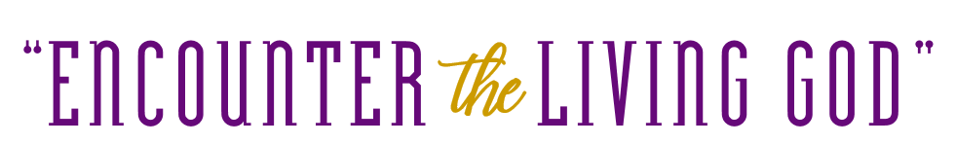
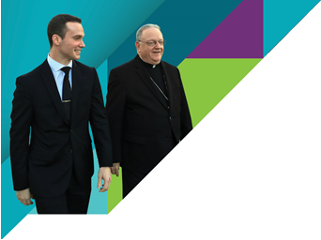
Your gift in support of the programs and ministries of the House of Charity, helps those in need to Encounter the Living God.

Social, Community and Health Care Services -
[Stand firm] “My brothers and sisters, think of the various tests you encounter as occasions for joy.” James 1:2
Your generosity provides services through Catholic Charities offices in each county of South Jersey. In addition, Home and Parish Healthcare Services of the
Diocese of Camden brings new life and spirit into the hearts of those we cherish the most – our elderly and disabled, along with their families and caregivers. Together, we
offer support to the weak, vulnerable and disenfranchised.

Evangelization and Faith Formation -
[Preparing for a divine encounter] “Then the Lord said to Moses, “I’m about to come to you in a thick cloud in order that the people will hear me talking with you so that they will always trust you.” Moses told the Lord what the people said…” Exodus 19:9
Lay leadership training, intercultural ministries, ministry with the deaf and persons with disabilities, marriage enrichment, adult faith formation, liturgical catechesis and other evangelization efforts, along with your gifts, kindle the fire of faith into a bright beacon for all to see.

Youth, Young Adult and Campus Ministries -
[Encounter at the threshing floor] “Naomi her mother-in-law said to her, “My daughter, shouldn’t I seek security for you, so that things might go well for you?” Ruth 3:1
Your donation enables programs like Summer in the City, Catholic Scouting, Theology on Tap, college campus ministries and Newman Centers, and support for a growing number of parish-based Youth Ministry programs and many more activities to build community and prepare our youth and young adults for the mission that God has chosen for them.

Vocations, Seminarian & Permanent Diaconate Formation, Care of Priests -
“My eyes encounter each hour of the night as I think about your word.” Psalm 119:148
Your support ensures that pastors and clergy continue to bring the light of Jesus into the world. Through prayers and support, we currently have 19 seminarians from the Diocese of Camden.

Catholic Education – “Forming minds and hearts in grace” -
“Train up a child in the way he should go; even when he is old he will not depart from it.” Proverbs 22:6
Catholic schools are an integral part of the teaching mission of the Church.
Catholic schools build faith, develop leadership ability and provide academic excellence in a safe environment.
Your gift will help keep tuition affordable for families to send children to schools that will support Catholic values, develop character and provide academic excellence.

Incentives for Parish Initiatives -
“Do not neglect to do good and to share what you have, for such sacrifices are pleasing to God.” Hebrews 13:6
When our parish collects its goal amount, up to 10% is returned to our parish for our local charitable needs. Additionally, 75% of all funds received above our parish goal will also be returned to our parish to foster our charitable and ministerial work.

Our goal here at __________ Parish is $_______.__ – but we have already raised an incredible $______.__ from the contributions of only ___ families! That’s an average gift of over $____.__! Now we invite all parishioners to participate in this important effort. During House of Charity Appeal Weekend, please make your sacrificial gift to help continue the mission of the Church here in the Diocese of Camden.

